Demographic Transition & Policy Analytics:
A Comprehensive Indian Population Study
Project Research Report | Prepared for Demographic & Policy Planning Analysis
1. Executive Summary
India stands at a pivotal junction in its demographic trajectory. Having officially overtaken China to become the world's most populous nation with approximately 1.44 billion citizens, India accounts for nearly 17.8% of the global population residing on just 2.4% of the world's land surface. However, aggregate population counts mask a sophisticated demographic transition marked by rapidly declining total fertility rates (TFR), expanding working-age population shares, and significant North-South regional divergences.
■ EXECUTIVE TAKEAWAY
India's Total Fertility Rate (TFR) has dropped to 1.9 nationally—below the replacement threshold of 2.1. Growth is now fueled entirely by demographic momentum rather than high reproduction, creating a finite 20-year window to leverage the demographic dividend.
2. Core Macro Demographic Metrics
The table below summarizes key structural indicators derived from recent Census estimates, National Family Health Surveys (NFHS-5), and UN Population Division data:
Demographic Metric | National Value | Analytical & Policy Context
Total Population | ~1.44 Billion | World's highest; projected peak at ~1.70B in 2062.
Annual Growth Rate | 0.86% | Decelerated from historical high of 2.41% in 1961.
Total Fertility Rate (TFR) | 1.90 | Below replacement level (2.1); sub-replacement across 28 states/UTs.
Median Age | 28.7 Years | Young labor force relative to China (39.0) and US (38.5).
Working-Age Share (15–64) | 68.2% | Core demographic dividend window peaking between 2035–2045.
Urbanization Rate | 36.4% | Accelerating rural-to-urban shift; projected >40% by 2030.

3. Age Structure & The Demographic Dividend Window
India is currently benefitting from a expansion in its working-age cohort. Unlike Western and East Asian economies experiencing acute workforce contraction, India's working-age ratio provides a powerful economic engine.
- Youth Cohort (0–14 years): Comprises ~24% of the population. Absolute youth numbers peaked in 2011 and are actively shrinking, reducing dependency pressure on school infrastructure.
- Working-Age Cohort (15–64 years): Comprises ~68% of the population (approx. 980 million individuals). This workforce pool provides massive labor market potential across service, manufacturing, and technology sectors.
- Elderly Cohort (65+ years): Comprises ~8% of the population. While currently low, this segment is growing at the fastest rate (+3.1% annually) and will double by 2045, requiring urgent geriatric healthcare planning.
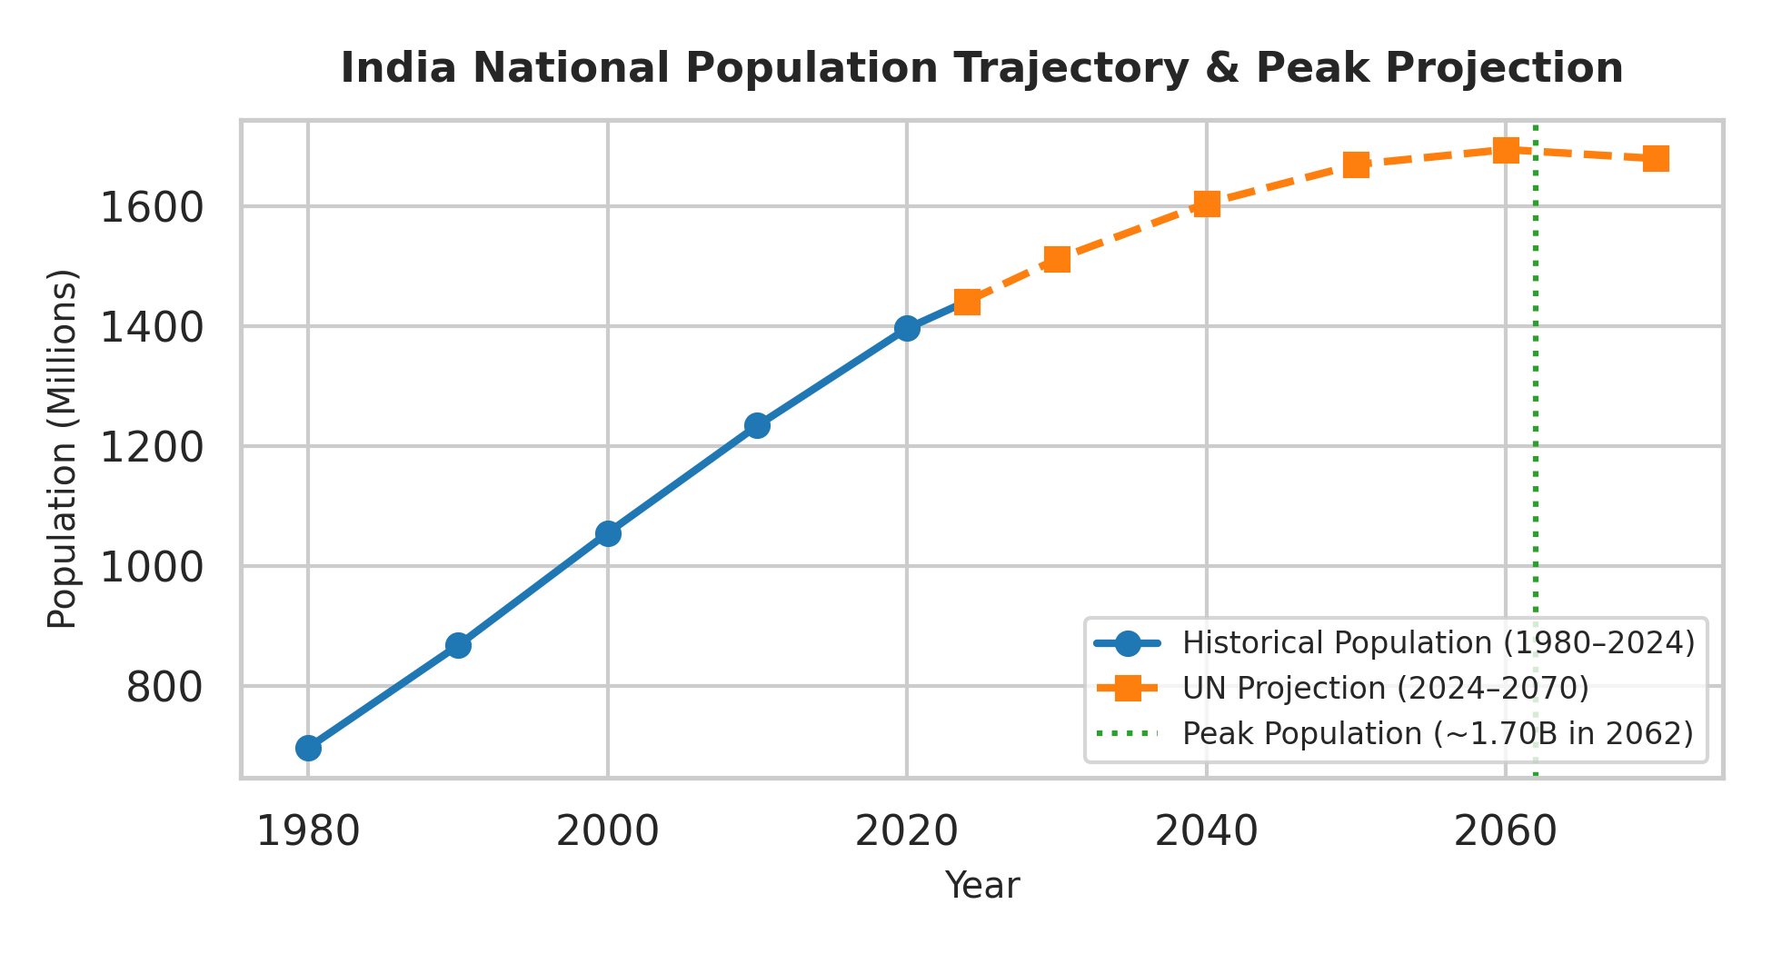

Figure 1: Historical India Population Growth & Projected Peak Trajectory (UN Data)

4. The North-South Regional Demographic Divide
A critical finding of this analysis is the sharp geographical polarization in fertility and demographic transition between India's northern/eastern states and southern/western states:
Southern & Western States (Advanced Transition)
States like Kerala (TFR 1.7), Tamil Nadu (1.8), Karnataka (1.7), and Maharashtra (1.7) completed their fertility transitions early. High female literacy, urban investment, and effective social welfare programs driven by state governance led to sub-replacement fertility. These states face impending workforce shortages, school closures, and an aging population profile.
Northern & Eastern States (Delayed Transition)
States such as Bihar (TFR 2.98), Uttar Pradesh (2.35), Madhya Pradesh (2.30), and Rajasthan (2.40) maintain fertility rates near or above replacement. Higher poverty rates, lower female educational attainment, and rural concentration account for sustained population expansion. These states possess a young workforce but face deficits in human capital investment.
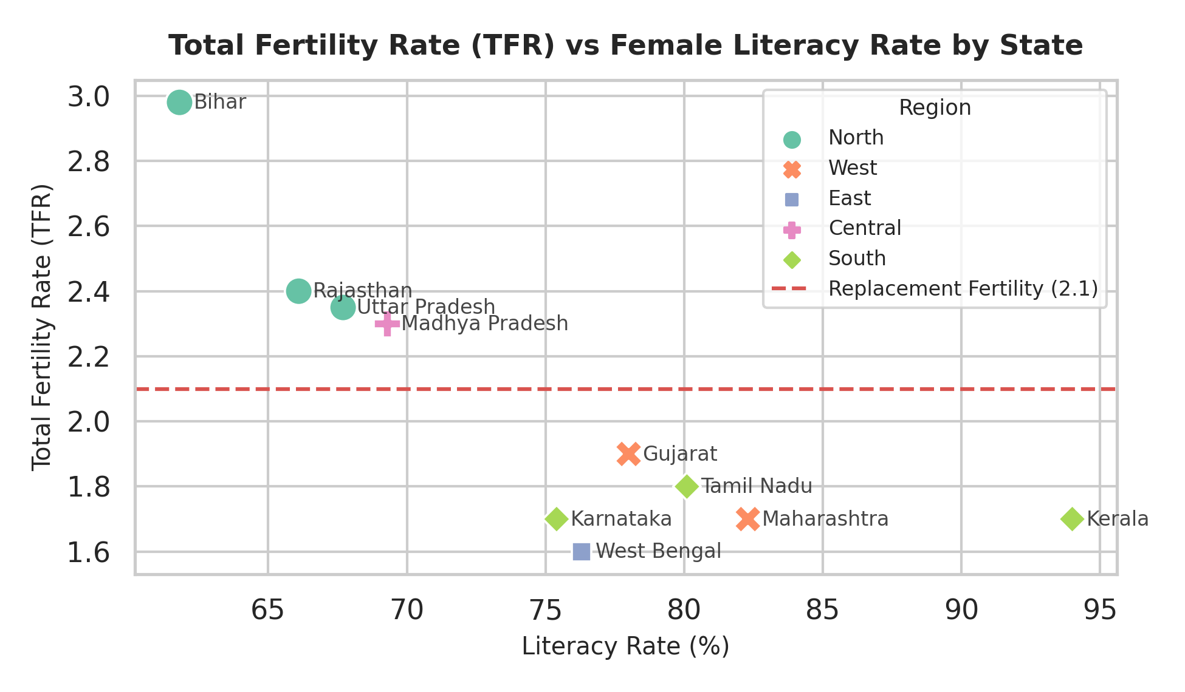
Figure 2: Empirical Correlation Between Female Literacy Rates and Total Fertility Rates (TFR)
5. Strategic Policy & Socio-Economic Implications
- Internal Labor Migration Flows: As southern states experience labor deficits and northern states experience youth surpluses, inter-state labor migration will surge. Policy must focus on portable social security, urban housing, and labor protections.
- Female Labor Force Participation (FLFP): Despite dropping fertility, female labor participation remains low (~32%). Unlocking economic growth requires skilling women and establishing formal caregiving infrastructure.
- Eldercare Infrastructure Realignment: Healthcare systems must shift from maternal-child health toward non-communicable disease management, geriatric care, and sustainable pension frameworks over the next 15 years.
- Political Representation & Delimitation: Demographic disparities pose federal political questions regarding parliament seat re-allocation (delimitation), balancing northern population expansion against southern demographic stabilization success.

6.References
- Data Sources
- Census of India: https://censusindia.gov.in/
- NFHS-5: http://rchiips.org/
- UN Population: https://population.un.org/
- World Bank: https://data.worldbank.org/
- Python Documentation
- Pandas: https://pandas.pydata.org/
- Matplotlib: https://matplotlib.org/
- Jupyter: https://jupyter.org/

